REPORT ON

PROJECT

PHASE

I

**Fingerprint based Attendance System**

SUBMITTED

TO

SAVITRIBAI PHULE PUN

E UNIVERSITY

FOR PARTIAL FULFILLM

ENT

OF THE REQUIREMENTS

FOR THE DEGREE OF

**BACHELOR OF ENGINEER**

**ING**

I

n

Electronics and Telecommunication

B

y

**Nihal Bandal(4507)**

**Sankalp Gupta(4520)**

**Hemant Dukre(4521)**

**DEPARTMENT OF ELECTR**

**ONICS AND TELECOMMUN**

**ICATION**

**PUNE INSTITUTE OF CO**

**MPUTER TECHNOLOGY**

**PUNE**

**–**

**43**

**OCTOBER**

**201**

**7**



Department of Electronics and Telecommunication Engineering

Pune Institute of Computer Technology, Pune – 43

CERTIFICATE

This is to certify that the Project Phase I Report entitled

**“Fingerprint based Attendance System”**

has been successfully completed by

Nihal Bandal (4507)

Sankalp Gupta (4520)

Hemant Dukre (4521)

towards the partial fulfillment of the degree of **Bachelorof Engineering** in **Electronics and Telecommunication** as awarded by the **Savitribai Phule Pune University**, at **Pune Institute of Computer Technology** during the academic year 2017-18.

Prof.Dr.Y.Ravinder Prof. Dr.Y.Ravinder

Project Guide HOD, E&TC Dept.

ACKNOWLEDGEMENTS

The completion of phase-I of this project could not have been possible without the participation and assistance of so many people whose names may not all be enumerated. Their contributions are sincerely appreciated and gratefully acknowledged. However, the group would like to express their deep appreciation and indebtedness particularly to the following:

We express a deep sense of gratitude to Dr. Y.Ravinder (Project Guide)for their valuable guidance, keen interest, constructive criticism and encouragement at various stages in completion of this project.

Last but not least, we would like to express our gratitude to our friends and respondents for support and willingness to be there with us, to share their support, either morally, financially and physically, thank you.

Thanking You

Nihal Bandal (4507)

Sankalp Gupta (4520)

Hemant Dukre (4521)

CONTENTS

|  |  |  |  |
| --- | --- | --- | --- |
|  | Abstract | | I |
|  | List of Acronyms | | II |
|  | List of Figures | | III |
|  |  | |  |
| 1 | Introduction | | 1-4 |
|  | 1.1 | Background | 1 |
|  | 1.2 | Relevance | 1 |
|  | 1.3 | Literature Survey | 2 |
|  | 1.4 | Motivation | 2 |
|  | 1.5 | Problem Definition | 3 |
|  | 1.6 | Scopes And Objectives | 3 |
|  | 1.7 | Technical Approach | 4 |
|  | 1.8 | Organization of the Report | 4 |
| 2 | Overview of Attendance System | | 5-17 |
|  | 2.1 | Introduction | 5 |
|  | 2.2 | Current Attendance System | 6 |
|  | 2.3 | Fingerprint Attendance System | 9 |
| 3 | Progress of Project and Discussion | | 18 |
| 4 | Conclusions | | 19 |
| 5 | Future Plan | | 20 |
| 6 | References | | 21 |

I

ABSTRACT

Our project aims at designing an student attendance system which could e executively manage attendance of students at institutes like PICT. Attendance is marked after student identification. For student identification, a fingerprint recognition based identification system is used. Fingerprints are considered to be the best and fastest method for biometric identification. They are secure to use, unique for every person and does not change in one's lifetime. Fingerprint recognition is a mature old to-day, but still identifying individual from a set of enrolled fingerprints is a time taking process. It was our responsibility to improve the fingerprint identification system for implementation on large databases e.g. of an institute or a country etc. In this project, many new algorithms have been used e.g. gender estimation, key based one to many matching, removing boundary minutiae. Using these new algorithms, we have developed an identification system which is faster in implementation than any other available today in the market. Although we are using this fingerprint identification system for student identification purpose in our project, the matching results are so good that it could perform very well on large databases like that of a country like India (MNIC Project).

This system was implemented in Matlab10, Intel Core2Duo processor and comparison of our one to many identification was done with existing identification technique i.e. one to one identification on same platform. Our matching technique runs in O(n+N) time as compared to the existing O(Nn2). The fingerprint identification system was tested on FVC2004 and Veringer databases

III

|  |  |  |
| --- | --- | --- |
| List of Figures | | |
| Figure 2.1 | Compatibility with current system |  |
| Figure 2.2 | Current Attendance System |  |
| Figure 2.3 | Fingerprint attendance system |  |
| Figure 2.4 | Flow chart of Fingerprint system |  |
| Figure 2.5 | Data flow Fingerprint attendance system |  |
| Figure 2.6 | ER Diagram for database |  |

CHAPTER 1

Introduction

# 1.1Background

Every organization whether it be an educational institution or business organization, it has to maintain a proper record of attendance of students or employees for effective functioning of organization. Designing a better attendance management system for students so that records be maintained with ease and accuracy was an important key behind motivating this project. This would improve accuracy of attendance records because it will remove all the hassles of roll calling and will save valuable time of the students as well as teachers.

Image processing and fingerprint recognition are very advanced today in terms of technology. It was our responsibility to improve fingerprint identification system. We decreased matching time by partitioning the database to one-tenth and improved matching using key based one to many matching

# 1.2Relevance

Biometric Identification Systems are widely used for unique identification of humans mainly for verification and identification. Biometrics is used as a form of identity access management and access control. So use of biometrics in student attendance management system is a secure approach. There are many types of biometric systems like fingerprint recognition, face recognition, voice recognition, iris recognition, palm recognition etc. In this project, we used fingerprint recognition system.

# 1.3Literature Survey

A fingerprint is the pattern of ridges and valleys on the surface of a fingertip. The endpoints and crossing points of ridges are called minutiae. It is a widely accepted assumption that the minutiae pattern of each finger is unique and does not change during one's life. Ridge endings are the points where the ridge curve terminates, and bifurcations are where a ridge splits from a single path to two paths at a Y-junction. Figure 1 illustrates an example of a ridge ending and a bifurcation. In this example, the black pixels correspond to the ridges, and the white pixels correspond to the valleys.

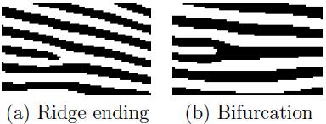

Figure 1.1: Example of a ridge ending and a bifurcation

When human fingerprint experts determine if two fingerprints are from the same finger, the matching degree between two minutiae pattern is one of the most important factors. Thanks to the similarity to the way of human fingerprint experts and compactness of templates, the minutiae-based matching method is the most widely studied matching method.

# 1.4 Motivation

Managing attendance records of students of an institute is a tedious task. It consumes time and paper both. To make all the attendance related work automatic and on-line, we have designed an attendance management system which could be implemented in PICT. It uses a fingerprint identification system developed in this project. This fingerprint identification system uses existing as well as new techniques in fingerprint recognition and matching. A new one to many matching algorithm for large databases has been introduced in this identification system.

# 1.5Problem Definition

Designing a student attendance management system based on fingerprint recognition and faster one to many identification that manages records for attendance in institutes like PICT.

# 1.6Scope and Objectives

Manual attendance taking and report generation has its limitations. It is well enough for 30-60 students but when it comes to taking attendance of students large in number, it is difficult. For taking attendance for a lecture, a conference, etc. roll calling and manual attendance system is a failure. Time waste over responses of students, waste of paper etc. are the disadvantages of manual attendance system. Moreover, the attendance report is also not generated on time. Attendance report which is circulated over PICT webmail is two months old. To overcome these non-optimal situations, it is necessary that we should use an automatic on-line attendance management sys-tem. So we present an implementable attendance management framework. Student attendance system framework is divided into three parts : Hardware/Software Design, Attendance Management Approach and On-line Report Generation. Each of these is explained below.

# 1.7Technical Approach

This part explains how students and teachers will use this attendance management system. Following points will make sure that attendance is marked correctly, without any problem:

(1)All the hardware will be inside classroom. So outside interference will be absent.

(2)To remove unauthorized access and unwanted attempt to corrupt the hardware by students, all the hardware except fingerprint scanner could be put inside a small

cabin. As an alternate solution, we can install CCTV cameras to prevent unprivileged activities.

(3)When teacher enters the classroom, the attendance marking will start. Computer software will start the process after inputting fingerprint of teacher. It will send the Subject ID, and Current Semester using the ID of the teacher or could be set manually on the software. If teacher doesn't enter classroom, attendance marking will not start.

(4)After some time, say 20 minutes of this process, no attendance will be given because of late entrance. This time period can be increased or decreased as per requirements.

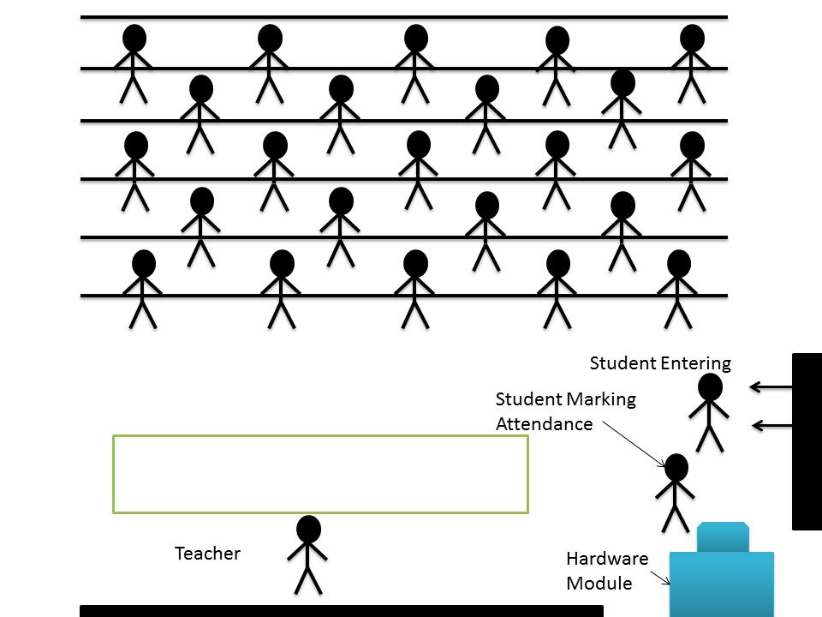

Figure 2.2: Classroom Scenario

# 1.8Organization of Report

* Chapter 1 consists of brief introduction of the project and brief details of different aspects of project such as Problem definition, technical details, Literature survey etc.
* Chapter 2 consist of detailed explanation about project. This chapter explains the idea of project in detail and also discusses stuff related to it. It explains the structure of current voting system and proposed Remote voting system. Also this explains the details about Remote voting system and compatibility of both systems. This chapter explains security features related to the project and database required for the project and their management.
* Chapter 3 shows the current progress of the project and work done so far in the project.
* Chapter 4 concludes this project report.
* Chapter 5 tells the future scope of the project.
* Chapter 6 contains the references for thee project.

CHAPTER 2

Overview of Fingerprint Based Attendance System

2.1 Introduction

Every organization whether it be an educational institution or business organization, it has to maintain a proper record of attendance of students or employees for effective functioning of organization. Designing a better attendance management system for students so that records be maintained with ease and accuracy was an important key behind motivating this project. This would improve accuracy of attendance records because it will remove all the hassles of roll calling and will save valuable time of the students as well as teachers.

Image processing and fingerprint recognition are very advanced today in terms of technology. It was our responsibility to improve fingerprint identification system. We decreased matching time by partitioning the database to one-tenth and improved matching using key based one to many matching

Attendance Management

Framework

Manual attendance taking and report generation has its limitations. It is well enough for 30-60 students but when it comes to taking attendance of students large in number, it is di cult. For taking attendance for a lecture, a conference, etc. roll calling and manual attendance system is a failure. Time waste over responses of students, waste of paper etc. are the disadvantages of manual attendance system. Moreover, the at-tendance report is also not generated on time. Attendance report which is circulated over NITR webmail is two months old. To overcome these non-optimal situations, it is necessary that we should use an automatic on-line attendance management sys-tem. So we present an implementable attendance management framework. Student attendance system framework is divided into three parts : Hardware/Software Design, Attendance Management Approach and On-line Report Generation. Each of these is explained below.

2.1 Hardware - Software Level Design

Required hardware used should be easy to maintain, implement and easily available.

Proposed hardware consists following parts:

(1)Fingerprint Scanner,

(2)LCD/Display Module (optional),

(3)Computer

|  |  |  |  |  |  |
| --- | --- | --- | --- | --- | --- |
|  |  | Table 2.1: Estimated Budget | | |  |
|  | Device | Cost of | Number of | Total | |
|  | Name | One Unit | Units Required | Unit Budget | |
|  |  |  |  |  |  |
|  | Scanner | 500 | 100 | 50000 |  |
|  | PC | 21000 | 100 | 2100000 |  |
|  |  |  |  |  |  |
|  | Total |  |  | 21,50,000 |  |
|  |  |  |  |  |  |

(4)LAN connection

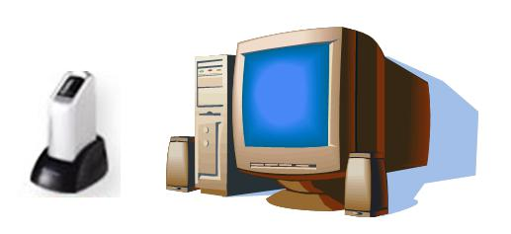Fingerprint scanner will be used to input ngerprint of teachers/students into the computer software. LCD display will be displaying rolls of those whose attendance is marked. Computer Software will be interfacing ngerprint scanner and LCD and will be connected to the network. It will input ngerprint, will process it and extract features for matching. After matching, it will update database attendance records of the students.

Figure 2.1: Hardware present in classrooms

Estimated Budget Estimated cost of the hardware for implementation of this system is shown in the table 2.1. Total number of classrooms in PICT is around 50. So number of units required will be 50.

2.2 Attendance Management Approach

This part explains how students and teachers will use this attendance management system. Following points will make sure that attendance is marked correctly, without any problem:

(1)All the hardware will be inside classroom. So outside interference will be absent.

(2)To remove unauthorized access and unwanted attempt to corrupt the hardware by students, all the hardware except fingerprint scanner could be put inside a small

cabin. As an alternate solution, we can install CCTV cameras to prevent unprivileged activities.

(3)When teacher enters the classroom, the attendance marking will start. Computer software will start the process after inputting ngerprint of teacher. It will nd the Subject ID, and Current Semester using the ID of the teacher or could be set manu-ally on the software. If teacher doesn't enter classroom, attendance marking will not start.

(4)After some time, say 20 minutes of this process, no attendance will be given because of late entrance. This time period can be increased or decreased as per requirement

2.3 On-Line Attendance Report Generation

Database for attendance would be a table having following elds as a combination for primary eld: (1)Day,(2)Roll,(3)Subject and following non-primary elds: (1)Atten-dance,(2)Semester. Using this table, all the attendance can be managed for a student. For on-line report generation, a simple website can be hosted on NIT Rourkela servers,

|  |  |
| --- | --- |
|  |  |

which will access this table for showing attendance of students. The sql queries will be used for report generation. Following query will give total numbers of classes held in subject CS423:

SELECT COUNT(DISTINCT Day) FROM AttendanceTable WHERE SUB-JECT = CS423 AND Attendance = 1

For attendance of roll 107CS016, against this subject, following query will be used: SELECT COUNT(Day) FROM AttendanceTable WHERE Roll = 107CS016 AND SUBJECT = CS423 AND Attendance = 1

Now the attendance percent can easily be calculated :

|  |  |  |  |
| --- | --- | --- | --- |
| Attendance = | ClassesAttended | 100 | (2.1) |
| ClassesHeld |

2.4 Network and Database Management

This attendance system will be spread over a wide network from classrooms via in-tranet to internet. Network diagram is shown in g. 2.3. Using this network, at-tendance reports will be made available over internet and e-mail. A monthly report will be sent to each student via email and website will show the updated attendance. Entity relationship diagram for database of students and attendance records is shown in g. 2.4. In ER diagram, primary elds are Roll, Date, SubjectID and TeacherID. Four tables are Student, Attendance, Subject and Teacher. Using this database, at-tendance could easily be maintained for students. Data ow is shown in data ow diagrams (DFD) shown in gures 2.5, 2.6 and 2.7.

2.5 Using wireless network instead of LAN and

bringing portability

We are using LAN for communication among servers and hardwares in the classrooms. We can instead use wireless LAN with portable devices. Portable device will have an embedded ngerprint scanner, wireless connection, a microprocessor loaded with a software, memory and a display terminal, see 2.5. Size of device could be small like a mobile phone depending upon how well the device is manufactured.

20 CHAPTER 2. ATTENDANCE MANAGEMENT FRAMEWORK

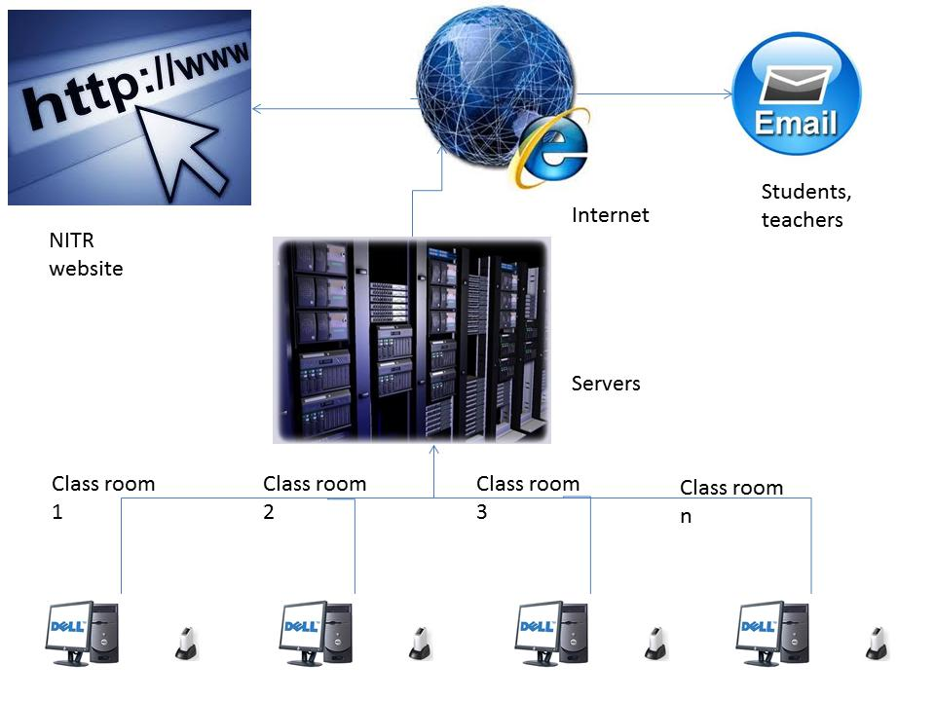

CHAPTER 3

Progress of Project and Discussion

Overview of the project is taken and some parts mentioned in section 1.7 are completed. Advantages and disadvantages of the project are discussed and problems faced while taking the overview are solved through the discussion with Project guide.

Initial installation of Raspbian OS on Raspberry Pi-3 and communicating and executing basic commands on Raspberry pi-3 using laptop is done. Also MySQL Queries for database implementation are studies. HTML for Web Development is also studied. Most important part of our database implementation i.e. ER Diagram is implemented. This ER-Diagram show the different relationship between different entities.

Installation of Apache server and php is successfully done in the Ubuntu environment. This server will be used in the server site to make communication between database and the webpage.

CHAPTER 4

Conclusions

* We learn about Raspberry Pi-3 and we have successfully installed the Raspbian OS on raspberry pi.
* Most important database management language i.e. MySQL is studied and small database of different entities is implemented in MySQL.
* We have learn about web development and HTML to create the webpages. Also, installing of apache server is studied and implemented successfully.
* Base of the project is completed and idea about remaining part is cleared.

CHAPTER 5

Future Plan

* Interfacing of fingerprint sensor with raspberry pi and reading the data from fingerprint sensor on raspberry pi is to be done.
* All the databases should be properly optimized and their linking with web using PHP is to be done.
* Sending fingerprint data over web using raspberry pi is to be done.
* Implementing https over apache server is to be done.
* Future of the project might be:
* As Indian is moving towards digitization we are converting all the current systems into digital ones, This is an approach to make voting procedure digital. This method can be further implemented to make all the voting’s using such kind of digital systems which makes counting procedure easier and also eliminates the fraud voted as this system ensures that 1 person can vote only ones using his Aadhaar details and also ensures that the person voting is same as who should be there based on fingerprint verification.

CHAPTER 6

References

1. Learning PHP, MySQL & JavaScript With jQuery, CSS & HTML5 -by Robin Nixon
2. Raspberry Pi-3 user manual.

Link: [http://www.cs.unca.edu/~bruce/Fall14/360/RPiUsersGuide.pdf](http://www.google.com/url?q=http%3A%2F%2Fwww.cs.unca.edu%2F~bruce%2FFall14%2F360%2FRPiUsersGuide.pdf&sa=D&sntz=1&usg=AFQjCNF1A5dc8KEnagbofq2LJNO7xdKEZg)

1. HTML Online Tutorials <https://www.w3schools.com/html/>